DoVER BEACH

The sea is calm tonight.
The tide is full, the moon lies fair
Upon the straits; on the French coast the light
Gleams and is gone; the cliffs of England stand,
Glimmering and vast, out in the tranquil bay.
Come to the window, sweet is the night-air!
Only, from the long line of spray
Where the sea meets the moon-blanched land,
Listen! you hear the grating roar
Of pebbles which the waves draw back, and fling,
At their return, up the high strand,
Begin, and cease, and then again begin,
With tremulous cadence slow, and bring
The eternal note of sadness in.

Sophocles long ago
Heard it on the Ægean, and it brought
Into his mind the turbid ebb and flow
Of human misery; we
Find also in the sound a thought,
Hearing it by this distant northern sea.

- In 1857, Arnold was elected to the professorship of poetry at Oxford. He was the first professor of poetry to give his lectures in English rather than in Latin. Although he began his literary career as a poet, Arnold is chiefly remembered for his critical essays. He is often considered to be the founding father of academic criticism in English, and an architect of the principles of literary criticism.

Matthew Arnold
(1822 -1888)
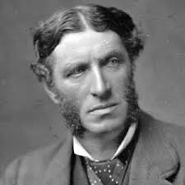

The Sea of Faith
Was once, too, at the full, and round earth’s shore
Lay like the folds of a bright girdle furled.
But now I only hear
Its melancholy, long, withdrawing roar,
Retreating, to the breath
Of the night-wind, down the vast edges drear
And naked shingles of the world.

Ah, love, let us be true
To one another! for the world, which seems
To lie before us like a land of dreams,
So various, so beautiful, so new,
Hath really neither joy, nor love, nor light,
Nor certitude, nor peace, nor help for pain;
And we are here as on a darkling plain
Swept with confused alarms of struggle and flight,
Where ignorant armies clash by night.

(1867)

